Our Daily Schedule

7:30 – 9:00 Free play and diapering/toileting
9:00 – 9:15 Group time
9:15 – 9:30 Snack
9:30 – 11:30 Free play / art / diapering & toileting
11:30 – 12:00 Outdoor play
12:00 – 12:30 Lunch / diapering & toileting
12:30 – 2:30 Naptime
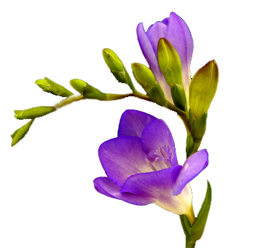
2:30 – 3:00 Transition from nap / diapering & toileting /
free play
3:00 – 3:15 Snack
3:15 – 3:30 Group time
3:30 – 5:30 Art / outdoor play / free play /
diapering & toileting

